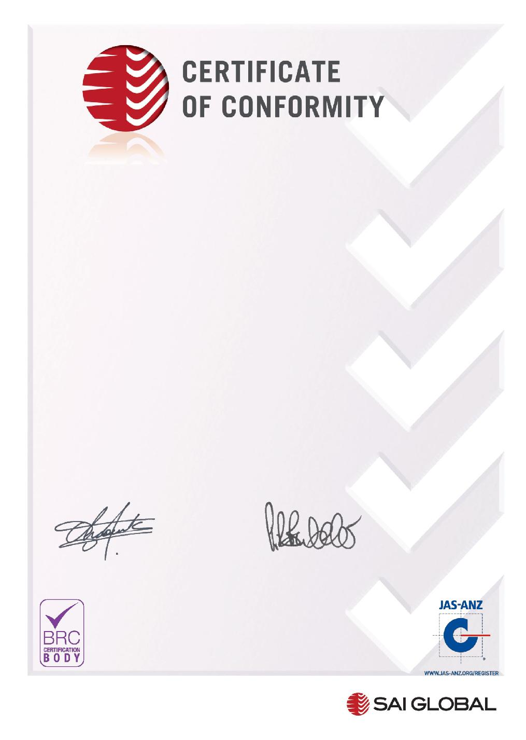

**This is to certify that:**

**Danisco Deutschland GmbH,**

**Niebull**

Busch-Johansen-Str. 1, D-25899, Germany

**BRC Site Code: 4390659** **Certificate Number: 325201**

has been audited by SAI Global and found to meet the requirements of

**Global Standard for Food Safety (IFS Food Standard version 6.1, ISO 22000:2018,   
ISO/TS 22002.1:2009, HACCP)**

**Achieved Grade: A**

Product Categories: 15 – Dried food and ingredients

**SCOPE:**

Production of food and feed ingredients e.g. emulsifiers, enzymes, antioxidants, antimicrobials, cultures, and blends thereof, amino acids, and starter media.

Scope exclusions: Production of non-food ingredients e.g. for plastics and active pharmaceutical ingredients. Audit Programme: Announced

**Auditor Number: 123085**

Date of Audit: 26,27,28-June-2019 Re-audit Due Date, From: 5-May-2020 To: 2-June-

2021

Certificate Issue Date: 30-June-2019 Certificate Expiry Date: 14-July-2021

Samer Chaouk Paul Butcher

Head of Policy, Risk and Certification Global Head – Assurance Services

Registered by:

SAI Global Certification Services Pty Ltd (ACN 108 716 669) 286 Sussex Street Sydney NSW 2000 Australia with SAI Global Assurance Services Ltd. Partis House, Ground Floor, Davy Avenue, Knowlhill, Milton Keynes, MK5 8HJ, United Kingdom (“SAI Global”) and subject to the SAI Global Terms and Conditions. While all due care and skill was exercised in carrying out this assessment, SAI Global accepts responsibility only for proven negligence. This certificate remains the property of SAI Global and must be returned to SAI Global upon its request.

*If you would like to feedback comments on the BRC Global Standard or the audit process directly to BRC, please contact* enquiries@brcglobalstandards.com

